**CONTENT:**

**Schools of Management Thoughts II**

The Social System School, Decision Theory School, The System School.

**OUTCOME:**

**After studying the Social System School, Decision Theory School, and the System School in management, expected outcomes such as:**

1. **Diverse Perspectives: Gain insights into various management approaches, broadening their understanding of organizational dynamics.**
2. **Critical Thinking: Develop critical thinking skills by evaluating different theories and their practical applications.**
3. **Problem-Solving Skills: Acquire valuable problem-solving skills, particularly from Decision Theory School, enhancing their ability to make effective decisions.**
4. **Systems Thinking: Understand organizations as interconnected systems, facilitating a holistic view of management.**
5. **Adaptability: Learn to adapt management strategies based on the context, fostering flexibility in approaching organizational challenges.**
6. **Practical Application: Apply theoretical concepts to real-world scenarios, preparing for challenges in actual managerial roles.**

**Studying these schools of thought equips students with a versatile skill set and knowledge base applicable to various managerial situations.**

1. **THE SOCIAL SYSTEM SCHOOL :-**

* This thought is closely linked to human behaviour school of thought.
* This school has been developed by researchers who regard management as a social system.
* The founding father of this school of thought was Chester I. Barnard.
* He viewed organisation as co-operative system involving co-operation among a number of groups.
* Barnard’s formal organisation concept consists of a cooperative system where persons are able to communicate with each other and willing to contribute action towards a conscious common purpose.
* This approach emphasizes the importance of understanding the social dynamics and cultural factors that influence organizational behavior and performance.
* Proponents of the social systems school of management argue that organizations are not just collections of individuals, but are complex networks of relationships and interactions that are shaped by culture, norms, and shared beliefs.
* They believe that understanding these social dynamics is essential for effectively managing organizations.
* One of the key concepts in the social systems school of management is the idea that organizations are open systems that are constantly interacting with their environment.
* This approach emphasizes the importance of understanding the external factors that influence organizational behavior and performance, such as the competitive landscape, economic conditions, and societal trends.
* Chester I. Barnard, an American management theorist, is best known for his work in the 1930s, particularly his **book "The Functions of the Executive"** published in 1938.
* Here are some key aspects of Barnard's theory:

1. **Acceptance Theory of Authority:**
   * One of Barnard's significant contributions is the "acceptance theory of authority."
   * He argued that a leader's authority is effective only when it is accepted by subordinates.
   * In other words, authority exists when subordinates are willing to follow the directives of a leader.

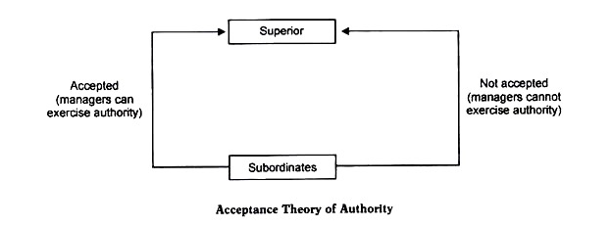

1. **Cooperation and Organizations:**
   * Barnard focused on the cooperative nature of organizations.
   * He believed that organizations are cooperative systems and that cooperation is vital for their functioning and success.
2. **Executive Functions:**
   * Barnard identified four essential functions of executives within an organization:
     + **Establishing and maintaining communication:** Executives need to ensure effective communication within the organization.
     + **Defining the organization's purpose:** Executives are responsible for clarifying the mission and goals of the organization.
     + **Securing essential services and resources:** Executives must make sure that necessary resources are available to achieve organizational goals.
     + **Creating a system of incentives:** Barnard emphasized the importance of providing incentives to encourage individuals to contribute to the organization.
3. **Informal Organizations:**
   * Barnard recognized the existence and importance of informal organizations within formal structures.
   * Informal relationships and networks play a crucial role in achieving organizational objectives.
4. **Formal Organization**

* Formal organization refers to the official structure of well-defined jobs, each being a measure of authority and responsibility.

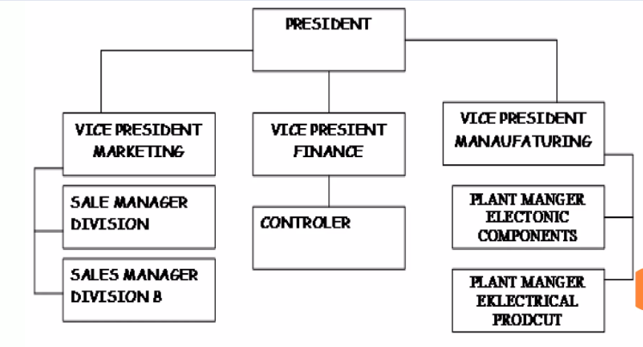

1. **Informal Organization**

* Informal organization refers to a network of social relations, which emerges on its own due to formal roles and relationships amongst people

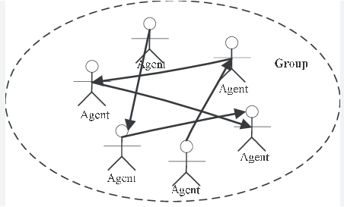

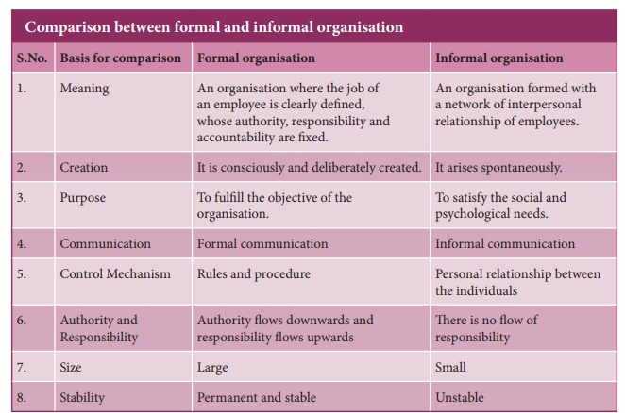

1. **Zone of Indifference:**
   * Barnard introduced the concept of the "zone of indifference," suggesting that employees will accept orders or directives that fall within the zone of indifference, meaning actions that are perceived as reasonable and not conflicting with personal values or interests.
2. **Authority and Responsibility:**
   * According to Barnard, authority and responsibility are interrelated.
   * If authority is accepted by subordinates, there is a corresponding responsibility to perform the tasks associated with that authority.
   * Barnard's theories laid the groundwork for later organizational and management theories, particularly those emphasizing the importance of human and social factors in organizations.
   * His work has influenced discussions on leadership, communication, and the complex interplay of formal and informal structures within organization.

* **The main features of this school of thought are:-**

1. Management is a social system, a system of Cultural relationships.
2. Formal organisations represent cultural relationships of the social groups working within the organisation.
3. People working together in groups have their own norms and values which have a bearing on the contribution that they are likely to make towards the goals of the organisation.
4. Cooperation and team spirit among the group members is necessary for the achievement of organisational objectives.
5. **DECISION THEORY :-**

* Herbert A Simon and James March are the pioneers of this school.
* The main contributors and thinkers belonging to this school of thought are Chester Bernard, James March, Herbert Simon, Forrester and Richard Cyert.
* The decision theory school lays emphasis on rational/balanced approach to decision-making,
* According to this school, the essence of management lies in decision making. Whatever a manager does that is the outcome of a decision made by him through rational choice from among different alternatives available to him.
* The decision theory school of management is a management philosophy that emphasizes the use of formal decision-making techniques and mathematical models to inform management decisions.
* It is based on the idea that organizations can be managed more effectively by using a systematic and logical approach to decision-making.
* Proponents of the decision theory school of management argue that organizations face a wide range of uncertain and complex decisions.
* They advocate the use of formal decision-making techniques, such as decision analysis, game theory, and operations research, to inform management decisions.
* The decision theory school of management typically involves the use of mathematical models and statistical analysis to evaluate different decision alternatives and to predict the outcomes of different actions.
* This information is then used to inform management decisions and to design organizational policies and practices that are more effective and efficient.
* Decision theory is a field of study that provides a systematic framework for analyzing and making decisions.
* It seeks to understand how individuals, groups, or organizations make choices and to develop rational criteria for making decisions.
* Decision theory draws on insights from mathematics, economics, psychology, and philosophy to model decision-making processes and provide guidance on how to make optimal choices in various situations.
* **Key components of decision theory include:**

1. **Decision-Making Agents:**
   * Decision theory focuses on entities known as decision-making agents. These agents could be individuals, groups, organizations, or even automated systems that face choices among different courses of action.
2. **Preferences:**
   * Central to decision theory is the idea of preferences. Decision-makers have preferences over different outcomes or states of the world. These preferences are often represented by utility functions, which assign a numerical value to each possible outcome based on the decision-maker's preferences.
3. **States of Nature:**
   * Decision problems involve uncertainty about the future. Decision theory typically considers a set of possible states of nature or future events. Decision-makers must choose actions without knowing for certain which state of nature will occur.
4. **Decision Trees:**
   * Decision trees are a common tool used in decision theory to visually represent decision problems. They help break down a complex decision into a series of sequential decisions and chance events, leading to different possible outcomes.
5. **Utility and Expected Utility:**
   * Utility is a measure of the satisfaction or desirability that an individual derives from a particular outcome. Expected utility is a key concept in decision theory, combining the utility of different outcomes with the probabilities of those outcomes to determine the overall expected satisfaction associated with a decision.
6. **Risk and Uncertainty:**
   * Decision theory distinguishes between risk and uncertainty. Risk involves situations where probabilities can be assigned to different outcomes, while uncertainty arises when probabilities are difficult or impossible to determine.
7. **Decision Criteria:**
   * Decision theorists often propose decision criteria to guide rational decision-making. Common criteria include maximizing expected utility, minimizing regret, and satisfying certain constraints.
8. **Game Theory:**
   * Game theory, a branch of decision theory, explores strategic interactions between decision-making agents. It is particularly relevant in situations where the outcome for one agent depends on the decisions of others.

Decision theory is applied in various fields, including economics, business, engineering, psychology, and artificial intelligence. It provides a systematic framework for analyzing choices, understanding human behavior in decision-making, and making optimal decisions in situations involving uncertainty and complexity.

* **Main features of this school of thought are:**

1. Management is essentially decision-making.
2. The members of any organisation are essentially decision-makers and problem solvers. Hence management is the study of the process of decision making and the personalities and behaviour of decision-makers.
3. The quality of decisions is a prime factor for increasing the efficiency of the organisation.
4. The quality of decisions is a prime factor for increasing the efficiency of the organisation.
5. **THE SYSTEM SCHOOL :-**

* The systems approach school is of recent origin having developed in late 1960’s.
* The prominent contributors to this school of thought are Kenneth, Boulding, Johnson, Cast Rosen Zweig and Churchman.
* This approach is based on the generalization that an organization is a system and its components are inter-related and inter-dependent.
* The effectiveness of system mainly depends upon the interdependency and inter-relations of the various sub-systems.
* The organization is responsive to environmental effect. It provides a strong conceptual framework for meaningful analysis and understanding of organizations.
* This approach is better than others because it is close to reality.

**Features of Systems Approach:**

* + 1. A system consists of interacting elements. It is set of inter-related and inter-dependent parts arranged in a manner that produces a unified whole.
    2. The various sub-systems should be studied in their inter-relationships rather, than in isolation from each other.
    3. An organisational system has a boundary that determines which parts are internal and which are external.
    4. A system does not exist in a vacuum. It receives information, material and energy from other systems as inputs. These inputs undergo a transformation process within a system and leave the system as output to other systems.
    5. An organisation is a dynamic system as it is responsive to its environment. It is vulnerable to change in its environment.

**Open System**

* An open system is one in which an organization receives varied forms of inputs from other systems.
* Open systems can also be internal sub-units that interact with other systems (or sub-units within other systems) that are outside of the organization.
* For example, a company receives supplies, information, raw materials, etc. These inputs are converted to outputs that affect other systems.

**Close system**

* Closed systems are the internal sub-units of the organization that do not interact with the external environment.

**The components of an organisational system as a open system:**

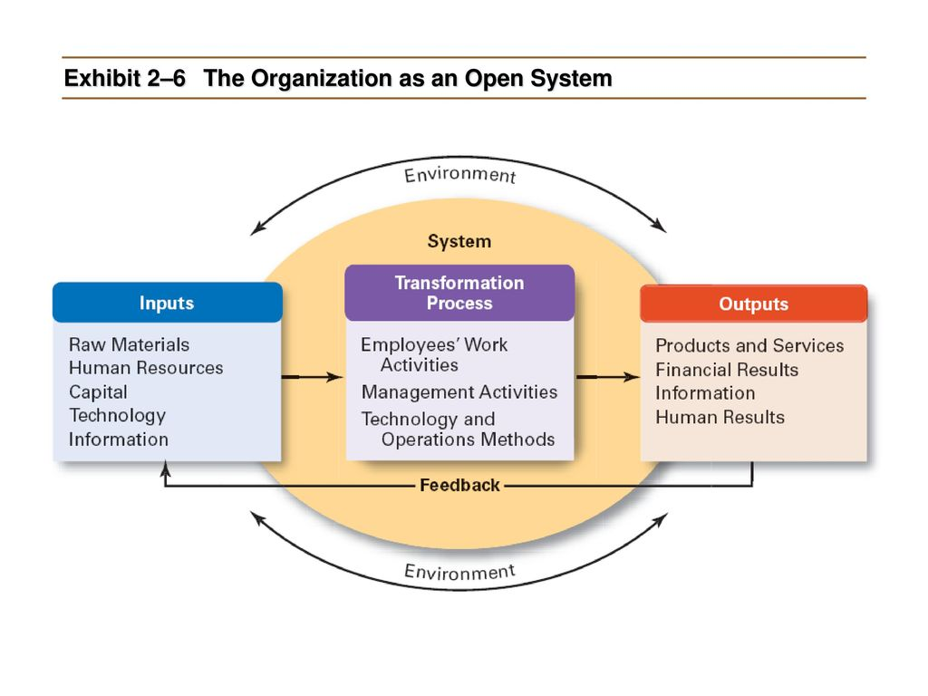

* **The main features of this school of thought are:**

1. A system has a number of sub-systems, parts and subparts.
2. All the subsystems, parts and subparts are mutually related to each other. This relationship is in the context of the whole and is very complex. A change in one part will effect changes in others.
3. The systems approach emphasises the study of the various parts in their inter-relationships rather than in isolate/lonely from each other.
4. The system approach to management brings out the complexity of a real life management problem much more sharply than any of the other approaches.

**MQC’s QUESTIONS**

**1. What is the central focus of the Social System School of Management Thought?**

a. Technology

b. Human behavior

c. Economic factors

d. Organizational structure

**Answer: b. Human behavior**

**2. Who is considered the key proponent of the Social System School?**

a. Peter Drucker

b. Chester Barnard

c. Frederick Taylor

d. Max Weber

**Answer: b. Chester Barnard**

**3. According to the Social System School, what plays a crucial role in achieving organizational goals?**

a. Technology

b. Formal structure

c. Informal organization

d. Centralization

**Answer: c. Informal organization**

**4. What term is used by the Social System School to describe the unwritten rules and norms within an organization?**

a. Formal structure

b. Organizational culture

c. Bureaucracy

d. Scientific management

**Answer: b. Organizational culture**

**5. According to Chester Barnard, what is the key element in the acceptance of authority?**

a. Power

b. Communication

c. Discipline

d. Leadership

**Answer: b. Communication**

**6. What does the Social System School emphasize regarding employee motivation?**

a. Financial incentives

b. Job design

c. Hierarchy of needs

d. Social relationships

**Answer: d. Social relationships**

**7. In the Social System School, what is the role of leadership in the organization?**

a. Strict control

b. Coordination

c. Decision-making

d. Task allocation

**Answer: b. Coordination**

**8. According to Chester Barnard, what is the purpose of organizations?**

a. Profit maximization

b. Goal attainment

c. Social responsibility

d. Innovation

**Answer: b. Goal attainment**

**9. Which concept emphasizes that authority should be commensurate with responsibility in organizations?**

a. Hierarchy

b. Scalar principle

c. Zone of indifference

d. Unity of command

**Answer: c. Zone of indifference**

**10. What term is used to describe the informal network of relationships within an organization?**

a. Grapevine

b. Hierarchy

c. Chain of command

d. Formal structure

**Answer: a. Grapevine**

**11. According to the Social System School, what is the primary source of authority in organizations?**

a. Legal power

b. Coercion

c. Acceptance

d. Positional hierarchy

**Answer: c. Acceptance**

**12. What is the main criticism of the Social System School?**

a. Neglect of formal structure

b. Overemphasis on hierarchy

c. Lack of focus on technology

d. Ignoring human aspects

**Answer: a. Neglect of formal structure**

**13. According to the Social System School, what should be the basis for the division of labor within an organization?**

a. Skills and expertise

b. Gender

c. Seniority

d. Educational qualifications

**Answer: a. Skills and expertise**

**14. What is the key concept in the Social System School that stresses the need for organizations to adapt to changing environments?**

a. Contingency theory

b. Organizational development

c. Open systems theory

d. Chaos theory

**Answer: c. Open systems theory**

**15. According to Chester Barnard, what is the significance of the executive's zone of indifference?**

a. It defines the scope of authority

b. It limits the decision-making power

c. It specifies the ethical boundaries

d. It outlines the range of acceptable orders

**Answer: a. It defines the scope of authority**

**16. What is the primary concern of the Social System School regarding employee participation?**

a. Power distribution

b. Job satisfaction

c. Employee empowerment

d. Efficiency improvement

**Answer: c. Employee empowerment**

**17. According to the Social System School, what contributes to the stability of an organization?**

a. Frequent changes

b. Dynamic leadership

c. Consistent norms

d. Rapid innovation

**Answer: c. Consistent norms**

**18. Which factor is emphasized by the Social System School for maintaining organizational equilibrium?**

a. Centralization

b. Flexibility

c. Formalization

d. Standardization

**Answer: b. Flexibility**

**19. According to Chester Barnard, what is the role of communication in organizations?**

a. Transmitting orders

b. Building relationships

c. Controlling employees

d. Centralizing authority

**Answer: b. Building relationships**

**20. What is the core idea behind the Social System School's approach to conflict within an organization?**

a. Avoidance

b. Resolution

c. Collaboration

d. Domination

**Answer: c. Collaboration**

**21. What is the Social System School's view on the informal organization's impact on formal goals?**

a. Detrimental

b. Irrelevant

c. Synergistic

d. Unpredictable

**Answer: c. Synergistic**

**22. According to Chester Barnard, what is the significance of the willingness to cooperate among organizational members?**

a. Job satisfaction

b. Social integration

c. Goal attainment

d. Authority distribution

**Answer: c. Goal attainment**

**23. In the Social System School, what is the importance of the concept of "zone of indifference" in organizational dynamics?**

a. Maintaining discipline

b. Reducing conflicts

c. Enhancing communication

d. Understanding employee behavior

**Answer: b. Reducing conflicts**

**24. What is the primary influence of social systems on organizational behavior, as per the Social System School?**

a. Economic factors

b. Cultural norms

c. Technological advancements

d. Legal regulations

**Answer: b. Cultural norms**

**25. According to the Social System School, what is the role of authority in organizations?**

a. Imposing control

b. Facilitating communication

c. Ensuring equality

d. Encouraging competition

**Answer: b. Facilitating communication**

**26. What is the main idea behind Chester Barnard's "Zone of Indifference"?**

a. Acceptance of authority

b. Employee autonomy

c. Conflict resolution

d. Decision-making power

**Answer: a. Acceptance of authority**

**27. According to the Social System School, what is the impact of informal groups on organizational behavior?**

a. Disruption

b. Productivity enhancement

c. Strict adherence to rules

d. Isolation

**Answer: b. Productivity enhancement**

**28. What concept is central to the Social System School's perspective on organizational change?**

a. Innovation

b. Resistance

c. Adaptation

d. Stability

**Answer: c. Adaptation**

**29. What does the Social System School consider as a source of power in organizations?**

a. Formal authority

b. Financial resources

c. Technological expertise

d. Employee motivation

**Answer: a. Formal authority**

**30. According to Chester Barnard, what is the significance of communication in organizations?**

a. Transmitting orders

b. Building relationships

c. Controlling employees

d. Centralizing authority

**Answer: b. Building relationships**

**31. What is the primary focus of the Decision Theory School of Management Thought?**

a. Organizational structure

b. Human behavior

c. Decision-making processes

d. Leadership styles

**Answer: c. Decision-making processes**

**32. Who is considered a prominent figure in the Decision Theory School of Management?**

a. Herbert Simon

b. Frederick Taylor

c. Max Weber

d. Elton Mayo

**Answer: a. Herbert Simon**

**33. According to Decision Theory, what is the rational decision-making process characterized by?**

a. Intuition

b. Emotional responses

c. Logical analysis

d. Random choices

**Answer: c. Logical analysis**

**34. In Decision Theory, what term is used to describe the tendency to rely on mental shortcuts and simplified decision rules?**

a. Risk aversion

b. Heuristics

c. Groupthink

d. Escalation of commitment

**Answer: b. Heuristics**

**35. What is the role of bounded rationality in Decision Theory?**

a. Complete rationality

b. Limited rationality

c. Emotional decision-making

d. Irrational choices

**Answer: b. Limited rationality**

**36. According to Herbert Simon, what is the primary limitation of perfect rationality in decision-making?**

a. Lack of information

b. Time constraints

c. Emotional bias

d. Overthinking

**Answer: b. Time constraints**

**37. Which type of decisions are made by managers in the routine course of their duties, according to Decision Theory?**

a. Programmed decisions

b. Non-programmed decisions

c. Strategic decisions

d. Tactical decisions

**Answer: a. Programmed decisions**

**38. What concept in Decision Theory refers to the tendency to favor information confirming existing beliefs or decisions?**

a. Confirmation bias

b. Groupthink

c. Anchoring effect

d. Availability heuristic

**Answer: a. Confirmation bias**

**39. According to Decision Theory, what is the term for the tendency to stick to a failing course of action?**

a. Escalation of commitment

b. Risk aversion

c. Satisficing

d. Anchoring effect

**Answer: a. Escalation of commitment**

**40. What does the term "satisficing" mean in the context of Decision Theory?**

a. Maximizing satisfaction

b. Accepting a satisfactory option

c. Minimizing risks

d. Avoiding decision-making

**Answer: b. Accepting a satisfactory option**

**41. In Decision Theory, what is the significance of the term "anchoring effect"?**

a. Relying on anchors in decision-making

b. Tendency to favor the first information encountered

c. Emphasizing group opinions

d. Overestimating probabilities

**Answer: b. Tendency to favor the first information encountered**

**42. According to Decision Theory, what is the main advantage of using decision trees in the decision-making process?**

a. Simplicity

b. Visual representation

c. Elimination of biases

d. Speed

**Answer: b. Visual representation**

**43. What is the primary goal of Decision Theory in the context of organizational decision-making?**

a. Eliminate emotions from decisions

b. Optimize decision outcomes

c. Minimize group discussions

d. Maximize intuitive choices

**Answer: b. Optimize decision outcomes**

**44. According to Herbert Simon, what is the term for the decision-making process where managers choose the first satisfactory alternative?**

a. Rational choice

b. Bounded rationality

c. Intuitive decision-making

d. Satisficing

**Answer: d. Satisficing**

**45. What role does intuition play in Decision Theory?**

a. Primary decision-making tool

b. Irrational influence

c. Hindrance to logical analysis

d. Emotional bias

**Answer: a. Primary decision-making tool**

**46. In Decision Theory, what is the term for decisions that involve unique problems and do not have a predetermined decision rule?**

a. Programmed decisions

b. Non-programmed decisions

c. Tactical decisions

d. Routine decisions

**Answer: b. Non-programmed decisions**

**47. What concept in Decision Theory refers to the tendency to make decisions based on readily available information?**

a. Anchoring effect

b. Availability heuristic

c. Confirmation bias

d. Escalation of commitment

**Answer: b. Availability heuristic**

**48. According to Decision Theory, what is the role of cognitive biases in decision-making?**

a. Enhance rationality

b. Improve accuracy

c. Introduce errors and deviations

d. Expedite decision processes

**Answer: c. Introduce errors and deviations**

**49. What is the term for a situation where decision-makers tend to focus on short-term benefits rather than long-term gains?**

a. Anchoring effect

b. Temporal discounting

c. Confirmation bias

d. Escalation of commitment

**Answer: b. Temporal discounting**

**50. According to Decision Theory, what is the impact of group decision-making on reducing individual biases?**

a. Groupthink

b. Confirmation bias

c. Diversification

d. Anchoring effect

**Answer: c. Diversification**

**51. What is the key difference between programmed and non-programmed decisions in Decision Theory?**

a. Frequency of occurrence

b. Level of complexity

c. Managerial hierarchy

d. Time required for decision-making

**Answer: b. Level of complexity**

**52. According to Herbert Simon, what term describes the process of making decisions without considering all available alternatives?**

a. Bounded rationality

b. Intuition

c. Escalation of commitment

d. Satisficing

**Answer: d. Satisficing**

**53. In Decision Theory, what is the term for decisions made based on personal values and beliefs rather than objective facts?**

a. Emotional decision-making

b. Intuitive decision-making

c. Rational decision-making

d. Heuristic decision-making

**Answer: b. Intuitive decision-making**

**54. What is the primary criticism of the Decision Theory School of Management?**

a. Overemphasis on rationality

b. Ignoring human emotions

c. Complexity of decision trees

d. Lack of focus on group dynamics

**Answer: a. Overemphasis on rationality**

**55. According to Decision Theory, what is the significance of the term "bounded rationality" in decision-making?**

a. Complete rationality

b. Limited rationality

c. Emotional decision-making

d. Irrational choices

**Answer: b. Limited rationality**

**56. What role does the concept of "risk" play in Decision Theory?**

a. Avoidance of decision-making

b. Introduction of uncertainties

c. Elimination of biases

d. Emphasis on emotional choices

**Answer: b. Introduction of uncertainties**

**57. According to Decision Theory, what is the purpose of decision analysis techniques?**

a. Increase emotional influence

b. Minimize group discussions

c. Optimize decision outcomes

d. Eliminate heuristics

**Answer: c. Optimize decision outcomes**

**58. What term is used in Decision Theory to describe the process of making decisions based on previous experiences and knowledge?**

a. Bounded rationality

b. Intuition

c. Escalation of commitment

d. Satisficing

**Answer: b. Intuition**

**59. According to Decision Theory, what is the significance of the term "groupthink" in decision-making?**

a. Enhances decision quality

b. Reduces biases

c. Hinders independent thinking

d. Promotes creativity

**Answer: c. Hinders independent thinking**

**60. In Decision Theory, what is the role of decision trees in the decision-making process?**

a. Introduce biases

b. Simplify complex decisions

c. Encourage emotional choices

d. Expedite decision processes

**Answer: b. Simplify complex decisions**

**61. What is the primary objective of using quantitative models in decision-making, as per Decision Theory?**

a. Increase emotional influence

b. Minimize group discussions

c. Optimize decision outcomes

d. Eliminate heuristics

**Answer: c. Optimize decision outcomes**

**62. According to Decision Theory, what is the significance of the term "escalation of commitment" in decision-making?**

a. Encourages risk-taking

b. Promotes stability

c. Tendency to stick to a failing course of action

d. Enhances rationality

**Answer: c. Tendency to stick to a failing course of action**

**63. What is the main advantage of using decision analysis techniques in Decision Theory?**

a. Eliminate biases

b. Simplify complex decisions

c. Optimize decision outcomes

d. Reduce time constraints

**Answer: a. Eliminate biases**

**64. According to Decision Theory, what is the role of emotions in the decision-making process?**

a. Rational decision-making

b. Emotional bias

c. Logical analysis

d. Satisficing

**Answer: b. Emotional bias**

**65. In Decision Theory, what is the term for the tendency to make decisions based on readily available information?**

a. Anchoring effect

b. Availability heuristic

c. Confirmation bias

d. Escalation of commitment

**Answer: b. Availability heuristic**

**66. According to Herbert Simon, what is the term for the decision-making process where managers choose the first satisfactory alternative?**

a. Rational choice

b. Bounded rationality

c. Intuitive decision-making

d. Satisficing

**Answer: d. Satisficing**

**67. What is the role of bounded rationality in Decision Theory?**

a. Complete rationality

b. Limited rationality

c. Emotional decision-making

d. Irrational choices

**Answer: b. Limited rationality**

**68. According to Decision Theory, what is the impact of group decision-making on reducing individual biases?**

a. Groupthink

b. Confirmation bias

c. Diversification

d. Anchoring effect

**Answer: c. Diversification**

**69. What role does the concept of "risk" play in Decision Theory?**

a. Avoidance of decision-making

b. Introduction of uncertainties

c. Elimination of biases

d. Emphasis on emotional choices

**Answer: b. Introduction of uncertainties**

**70. According to Decision Theory, what is the significance of the term "groupthink" in decision-making?**

a. Enhances decision quality

b. Reduces biases

c. Hinders independent thinking

d. Promotes creativity

**Answer: c. Hinders independent thinking**

**71. What is the primary focus of the System School of Management Thought?**

a. Human behavior

b. Organizational structure

c. Interconnectedness and interdependence

d. Decision-making processes

**Answer: c. Interconnectedness and interdependence**

**72. Who is a key figure associated with the System School of Management?**

a. Frederick Taylor

b. Max Weber

c. Peter Drucker

d. Chester Barnard

**Answer: c. Peter Drucker**

**73. According to the System School, how are the components within an organization interconnected?**

a. Hierarchically

b. Independently

c. Sequentially

d. Interdependently

**Answer: d. Interdependently**

**74. In the System School, what does the term "subsystem" refer to within an organization?**

a. Individual employees

b. Departments or units

c. External stakeholders

d. Organizational goals

**Answer: b. Departments or units**

**75. According to the System School, what is the primary goal of an organization within its environment?**

a. Profit maximization

b. Stability

c. Adaptation

d. Efficiency

**Answer: c. Adaptation**

**76. What concept in the System School emphasizes the continuous interaction between an organization and its external environment?**

a. Feedback loop

b. Open systems

c. Closed systems

d. Contingency theory

**Answer: b. Open systems**

**77. According to the System School, what is the purpose of feedback mechanisms in an organization?**

a. Maintain status quo

b. Facilitate communication

c. Enhance efficiency

d. Adapt to changes

**Answer: d. Adapt to changes**

**78. What is the term used in the System School to describe the inputs an organization receives from its environment?**

a. Throughputs

b. Outputs

c. Feedback

d. Inputs

**Answer: d. Inputs**

**79. According to the System School, what is the term for the products, services, or outcomes produced by an organization?**

a. Inputs

b. Throughputs

c. Outputs

d. Feedback

**Answer: c. Outputs**

**80. What concept in the System School emphasizes the need for organizations to be responsive to changes in their external environment?**

a. Feedback loop

b. Contingency theory

c. Adaptability

d. Stability

**Answer: c. Adaptability**

**81. In the System School, what is the term for the process by which an organization transforms inputs into outputs?**

a. Throughputs

b. Feedback loop

c. Adaptation

d. Contingency

**Answer: a. Throughputs**

**82. According to the System School, what role does entropy play in organizational systems?**

a. Promotes stability

b. Encourages innovation

c. Leads to disorder and decline

d. Enhances efficiency

**Answer: c. Leads to disorder and decline**

**83. What is the significance of the term "equifinality" in the System School?**

a. Multiple paths to the same goal

b. One path to multiple goals

c. Singular path to a singular goal

d. No defined path to any goal

**Answer: a. Multiple paths to the same goal**

**84. According to the System School, what is the role of boundaries in defining an organization?**

a. Limiting interactions

b. Facilitating adaptability

c. Encouraging innovation

d. Establishing hierarchies

**Answer: a. Limiting interactions**

**85. What concept in the System School highlights the mutual influence between an organization and its external environment?**

a. Closed systems

b. Open systems

c. Subsystems

d. Contingency theory

**Answer: b. Open systems**

**86. According to the System School, what happens when an organization fails to adapt to changes in its environment?**

a. Stability is maintained

b. Entropy increases

c. Equifinality is achieved

d. Feedback loops intensify

**Answer: b. Entropy increases**

**87. What is the primary criticism of the System School of Management Thought?**

a. Overemphasis on adaptability

b. Ignoring internal processes

c. Lack of attention to human behavior

d. Neglecting external factors

**Answer: c. Lack of attention to human behavior**

**88. According to the System School, what is the role of internal subsystems within an organization?**

a. Isolation from the external environment

b. Enhancing stability

c. Facilitating adaptability

d. Minimizing feedback mechanisms

**Answer: c. Facilitating adaptability**

**89. What does the term "contingency" refer to in the System School?**

a. Unpredictable events

b. Stable conditions

c. Feedback mechanisms

d. Closed systems

**Answer: a. Unpredictable events**

**90. According to the System School, what is the significance of negative entropy for an organization?**

a. Promotes stability

b. Encourages innovation

c. Prevents disorder and decline

d. Enhances efficiency

**Answer: c. Prevents disorder and decline**

**91. What is the role of a manager in the System School's perspective on organizational management?**

a. Focus on individual tasks

b. Adapt to external changes

c. Maintain stability

d. Minimize interactions

**Answer: b. Adapt to external changes**

**92. According to the System School, what is the significance of the term "suboptimization" in organizational systems?**

a. Maximizing efficiency

b. Maximizing adaptability

c. Maximizing outputs

d. Maximizing subsystem performance at the expense of the whole system

**Answer: d. Maximizing subsystem performance at the expense of the whole system**

**93. What does the term "synergy" imply in the context of the System School?**

a. Negative interactions

b. Positive interactions

c. Closed systems

d. Subsystem isolation

**Answer: b. Positive interactions**

**94. According to the System School, what is the role of feedback loops in organizational systems?**

a. Preventing adaptation

b. Enhancing stability

c. Minimizing interactions

d. Facilitating adaptation

**Answer: d. Facilitating adaptation**

**95. What is the term for a situation where an organization achieves its goals using various means and strategies?**

a. Equifinality

b. Entropy

c. Synergy

d. Suboptimization

**Answer: a. Equifinality**

**96. According to the System School, what is the significance of the term "closed systems" in organizational contexts?**

a. Interaction with the external environment

b. Isolation from the external environment

c. Equifinality

d. Entropy reduction

**Answer: b. Isolation from the external environment**

**97. In the System School, what is the role of a manager in maintaining equilibrium within an organization?**

a. Minimizing interactions

b. Enhancing adaptability

c. Stabilizing conditions

d. Ignoring external changes

**Answer: c. Stabilizing conditions**

**98. According to the System School, what is the significance of "positive entropy" in organizational systems?**

a. Promotes disorder

b. Enhances stability

c. Encourages adaptability

d. Prevents suboptimization

**Answer: c. Encourages adaptability**

**99. What term is used to describe the process by which an organization adjusts its structure and processes in response to environmental changes?**

a. Synergy

b. Adaptation

c. Suboptimization

d. Entropy

**Answer: b. Adaptation**

**100. According to the System School, what is the impact of synergy on organizational performance?**

a. Negative interactions

b. Positive interactions

c. Closed systems

d. Subsystem isolation

**Answer: b. Positive interactions**